**Program No: 01 Date:10-08-2022**

**Aim**: Design a login form with Username and Password using linear layout and toast valid credentials.

**Program Code:**

**activity.xml**

*<?*xml version="1.0" encoding="utf-8"*?>*<LinearLayout  
 xmlns:android="http://schemas.android.com/apk/res/android"  
 xmlns:app="http://schemas.android.com/apk/res-auto"  
 xmlns:tools="http://schemas.android.com/tools"  
 android:layout_width="match_parent"  
 android:layout_height="match_parent"  
 tools:context=".MainActivity"  
 android:orientation="vertical">  
  
 <TextView  
 android:layout_width="wrap_content"  
 android:layout_height="wrap_content"  
 android:text="Login"  
 android:textSize="@dimen/cardview_default_radius"/>  
  
 <EditText  
 android:layout_width="match_parent"  
 android:layout_height="wrap_content"  
 android:hint="username"  
 android:id="@+id/et1"  
 />  
 <EditText  
 android:layout_width="match_parent"  
 android:layout_height="wrap_content"  
 android:hint="password"  
 android:id="@+id/et2"  
 android:layout_marginTop="10dp"  
 android:inputType="textPassword"  
 />  
 <Button  
 android:layout_width="wrap_content"  
 android:layout_height="wrap_content"  
 android:text="Login"  
 android:id="@+id/btn"  
 android:layout_marginLeft="140dp"  
 />

</LinearLayout>

**Mainactivity.java**

package com.example.prg1;  
import androidx.appcompat.app.AppCompatActivity;  
  
import android.os.Bundle;  
import android.view.View;  
import android.widget.Button;  
import android.widget.EditText;  
import android.widget.Toast;  
  
public class MainActivity extends AppCompatActivity {  
  
 @Override  
 protected void onCreate(Bundle savedInstanceState) {  
 super.onCreate(savedInstanceState);  
 setContentView(R.layout.*activity_main*);  
 EditText et1=findViewById(R.id.*et1*);  
 EditText et2=findViewById(R.id.*et2*);  
 Button button=findViewById(R.id.*btn*);  
button.setOnClickListener(new View.OnClickListener() { @Override  
 public void onClick(View view) {  
 validate(et1.getText().toString(),et2.getText().toString());  
 }  
 private void validate(String us,String pw)  
 {  
 if(us.equals("admin")&&pw.equals("1234"))  
 {  
 Toast.*makeText*(getApplicationContext(),"Login successfull",Toast.*LENGTH_LONG*).show();  
 }  
 else  
 {  
 Toast.*makeText*(getApplicationContext(),"Unsuccessfull login",Toast.*LENGTH_LONG*).show();  
 }  
 }  
 });  
 }  
}

**Result:** Program compiled successfully and output verified.

**Output**

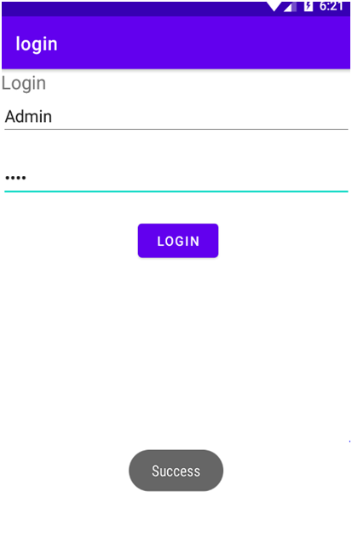

**Program No: 02 Date:16-08-2022**

**Aim**: Write a program to demonstrate the activity life cycle.

**Program Code:**

**activity.xml**

*<?*xml version="1.0" encoding="utf-8"*?>*<androidx.constraintlayout.widget.ConstraintLayout xmlns:android="http://schemas.android.com/apk/res/android"  
 xmlns:app="http://schemas.android.com/apk/res-auto"  
 xmlns:tools="http://schemas.android.com/tools"  
 android:layout_width="match_parent"  
 android:layout_height="match_parent"  
 tools:context=".MainActivity">  
  
 <TextView  
 android:layout_width="wrap_content"  
 android:layout_height="wrap_content"  
 android:text="Hello World!"  
 app:layout_constraintBottom_toBottomOf="parent"  
 app:layout_constraintLeft_toLeftOf="parent"  
 app:layout_constraintRight_toRightOf="parent"  
 app:layout_constraintTop_toTopOf="parent" />

**Mainactivity.java**

package com.example.myapplication;  
  
import androidx.appcompat.app.AppCompatActivity;  
  
import android.os.Bundle;  
import android.util.Log;  
  
public class MainActivity extends AppCompatActivity {  
  
 @Override  
 protected void onCreate(Bundle savedInstanceState) {  
 super.onCreate(savedInstanceState);  
 setContentView(R.layout.*activity_main*);  
 Log.*d*("lifecycle","onCreate invoked");  
 }  
 @Override  
 protected void onStart() {  
 super.onStart();  
 Log.*d*("lifecycle","onStart invoked");  
 }  
 @Override  
 protected void onResume() {  
 super.onResume();  
 Log.*d*("lifecycle","onResume invoked");  
 }  
 @Override  
 protected void onPause() {  
 super.onPause();  
 Log.*d*("lifecycle","onPause invoked");  
 }  
 @Override  
 protected void onStop() {  
 super.onStop();  
 Log.*d*("lifecycle","onStop invoked");  
 }  
 @Override  
 protected void onRestart() {  
 super.onRestart();  
 Log.*d*("lifecycle","onRestart invoked");  
 }  
 @Override  
 protected void onDestroy() {  
 super.onDestroy();  
 Log.*d*("lifecycle","onDestroy invoked");  
 }  
}

**Result:** Program compiled successfully and output verified.

**Output**

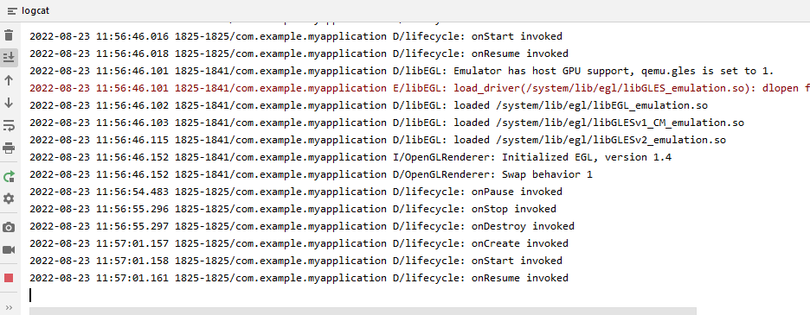

**Program No: 03 Date:19-08-2022**

**Aim**:Implementing basic arithmetic operations of a simple calculator.

**Program Code:**

**activity.xml**

*<?*xml version="1.0" encoding="utf-8"*?>*<LinearLayout  
 xmlns:android="http://schemas.android.com/apk/res/android"  
 xmlns:app="http://schemas.android.com/apk/res-auto"  
 xmlns:tools="http://schemas.android.com/tools"  
 android:layout_width="match_parent"  
 android:layout_height="match_parent"  
 tools:context=".MainActivity"  
 android:orientation="vertical">  
  
 <TextView  
 android:layout_width="wrap_content"  
 android:layout_height="wrap_content"  
 android:text="Simple calculator"/>  
 <TextView  
 android:layout_width="match_parent"  
 android:layout_height="wrap_content"  
 android:text="Enter 1st number"/>  
 <EditText  
 android:layout_width="wrap_content"  
 android:layout_height="wrap_content"  
 android:hint="Enter 1st number"  
 android:id="@+id/n1"/>  
 <TextView  
 android:layout_width="match_parent"  
 android:layout_height="wrap_content"  
 android:text="Enter the 2nd number"/>  
 <EditText  
 android:layout_width="wrap_content"  
 android:layout_height="wrap_content"  
 android:hint="Enter the 2nd number"  
 android:id="@+id/n2"/>  
 <TextView  
 android:layout_width="wrap_content"  
 android:layout_height="wrap_content"  
 android:id="@+id/t1"/>  
 <LinearLayout  
 android:layout_width="wrap_content"  
 android:layout_height="wrap_content">  
 <Button  
 android:layout_width="wrap_content"  
 android:layout_height="wrap_content"  
 android:text="Add"  
 android:id="@+id/b1"/>  
 <Button  
 android:layout_width="wrap_content"  
 android:layout_height="wrap_content"  
 android:text="Sub"  
 android:id="@+id/b2"/>  
 <Button  
 android:layout_width="wrap_content"  
 android:layout_height="wrap_content"  
 android:text="Mul"  
 android:id="@+id/b3"/>  
 <Button  
 android:layout_width="wrap_content"  
 android:layout_height="wrap_content"  
 android:text="Div"  
 android:id="@+id/b4"/>  
 </LinearLayout>  
  
</LinearLayout>

**Mainactivity.java**

package com.example.calculator;  
  
import androidx.appcompat.app.AppCompatActivity;  
  
import android.os.Bundle;  
import android.view.View;  
import android.widget.Button;  
import android.widget.EditText;  
import android.widget.TextView;  
  
public class MainActivity extends AppCompatActivity {  
  
 @Override  
 protected void onCreate(Bundle savedInstanceState) {  
 super.onCreate(savedInstanceState);  
 setContentView(R.layout.*activity_main*);  
 EditText t1=findViewById(R.id.*n1*);  
 EditText t2=findViewById(R.id.*n2*);  
 Button add=findViewById(R.id.*b1*);  
 Button sub=findViewById(R.id.*b2*);  
 Button mul=findViewById(R.id.*b3*);  
 Button div=findViewById(R.id.*b4*);  
 TextView tv1=findViewById(R.id.*t1*);  
 add.setOnClickListener(new View.OnClickListener() {  
 @Override  
 public void onClick(View view) {  
 Double a1 = Double.*parseDouble*(t1.getText().toString());  
 Double a2 = Double.*parseDouble*(t2.getText().toString());  
 Double r = a1 + a2;  
 tv1.setText("Result is: " + String.*valueOf*(r));  
 }  
 });  
 sub.setOnClickListener(new View.OnClickListener() {  
 @Override  
 public void onClick(View view) {  
 Double s1=Double.*parseDouble*(t1.getText().toString());  
 Double s2=Double.*parseDouble*(t2.getText().toString());  
 Double r=s1-s2;  
 tv1.setText("Result is: "+String.*valueOf*(r));  
 }  
 });  
 mul.setOnClickListener(new View.OnClickListener() {  
 @Override  
 public void onClick(View view) {  
 Double m1 = Double.*parseDouble*(t1.getText().toString());  
 Double m2 = Double.*parseDouble*(t2.getText().toString());  
 Double r = m1 * m2;  
 tv1.setText("Result is" + String.*valueOf*(r));  
  
 }  
 });  
 div.setOnClickListener(new View.OnClickListener() {  
 @Override  
 public void onClick(View view) {  
 Double d1=Double.*parseDouble*(t1.getText().toString());  
 Double d2=Double.*parseDouble*(t2.getText().toString());  
 Double r=d1/d2;  
 tv1.setText("Result is" +String.*valueOf*(r));  
 }  
 });  
  
  
 }  
  
}

**Result:** Program compiled successfully and output verified.

**Output**

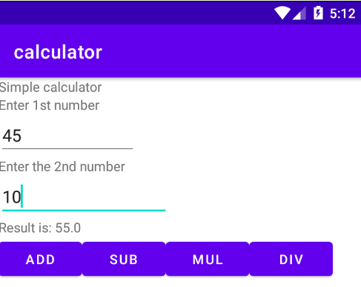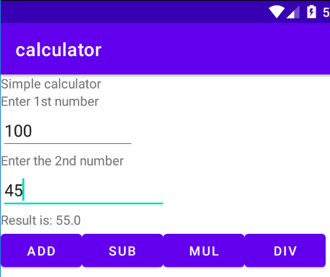

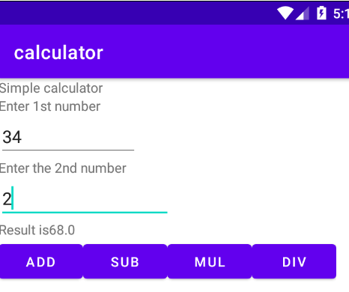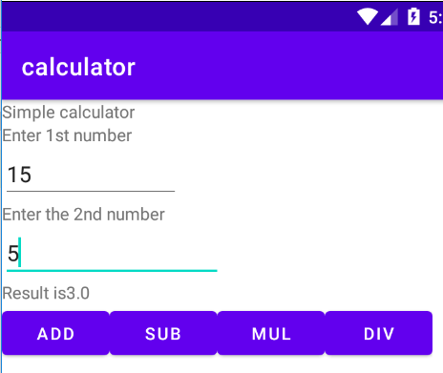

**Program No: 04 Date:23-08-2022**

**Aim**:Implement validation on various UI controls.

**Program Code:**

**activity.xml**

*<?*xml version="1.0" encoding="utf-8"*?>*<LinearLayout xmlns:android="http://schemas.android.com/apk/res/android"  
 xmlns:app="http://schemas.android.com/apk/res-auto"  
 xmlns:tools="http://schemas.android.com/tools"  
 android:layout_width="match_parent"  
 android:layout_height="match_parent"  
 android:orientation="vertical"  
 tools:context=".MainActivity">  
  
 <TextView  
 android:layout_width="match_parent"  
 android:layout_height="wrap_content"  
 android:text="REGISTRATION"  
 android:textColor="@color/design_default_color_error"  
 android:textSize="30dp"/>  
 <EditText  
 android:layout_width="match_parent"  
 android:layout_height="wrap_content"  
 android:hint="NAME"  
 android:id="@+id/name"/>  
 <EditText  
 android:layout_width="match_parent"  
 android:layout_height="wrap_content"  
 android:hint="MOBILE NUMBER"  
 android:id="@+id/mobile"/>  
 <EditText  
 android:layout_width="match_parent"  
 android:layout_height="wrap_content"  
 android:hint="AGE"  
 android:id="@+id/age"/>  
 <TextView  
 android:layout_width="wrap_content"  
 android:layout_height="wrap_content"  
 android:text="GENDER"  
 android:textSize="20dp"  
 android:textColor="@color/design_default_color_primary"/>  
 <RadioGroup  
 android:layout_width="wrap_content"  
 android:layout_height="wrap_content"  
 android:id="@+id/RG">  
 <RadioButton  
 android:layout_width="wrap_content"  
 android:layout_height="wrap_content"  
 android:id="@+id/radiobutton1"  
 android:text="Male"/>  
 <RadioButton  
 android:layout_width="wrap_content"  
 android:layout_height="wrap_content"  
 android:id="@+id/radiobutton2"  
 android:text="Female"/>  
 </RadioGroup>  
 <Button  
 android:layout_width="wrap_content"  
 android:layout_height="wrap_content"  
 android:text="Submit"  
 android:id="@+id/button"/>  
 <CheckBox  
 android:layout_width="wrap_content"  
 android:layout_height="wrap_content"  
 android:text="i agree all terms and conditions"  
 android:id="@+id/checkbox"/>

</LinearLayout

**Mainactivity.java**

package com.example.validation;  
  
import androidx.appcompat.app.AppCompatActivity;  
  
import android.content.Intent;  
import android.os.Bundle;  
import android.view.View;  
import android.widget.Button;  
import android.widget.CheckBox;  
import android.widget.EditText;  
import android.widget.RadioButton;  
import android.widget.RadioGroup;  
import android.widget.Toast;  
  
public class MainActivity extends AppCompatActivity {  
 EditText name;  
 EditText mobileno;  
 EditText age;  
 RadioGroup radiogroup;  
 RadioButton male;  
 RadioButton female;  
 CheckBox checkbox;  
 Button button;  
  
 @Override  
 protected void onCreate(Bundle savedInstanceState) {  
 super.onCreate(savedInstanceState);  
 setContentView(R.layout.*activity_main*);  
 name=findViewById(R.id.*name*);  
 mobileno=findViewById(R.id.*mobile*);  
 age=findViewById(R.id.*age*);  
 radiogroup=findViewById(R.id.*RG*);  
 male=findViewById(R.id.*radiobutton1*);  
 female=findViewById(R.id.*radiobutton2*);  
 checkbox=findViewById(R.id.*checkbox*);  
 button=findViewById(R.id.*button*);  
 button.setOnClickListener(new View.OnClickListener() {  
 @Override  
 public void onClick(View view) {  
 if (error()){  
 Intent i=new Intent(MainActivity.this,login.class);  
 startActivity(i);  
 }  
 }  
 });  
 }  
 private boolean error(){  
 if (name.getText().toString().length()==0){  
 Toast.*makeText*(getApplicationContext(),"Please enter the name",Toast.*LENGTH_LONG*).show();  
 return false;  
 }else if (mobileno.getText().toString().length()==0){  
 Toast.*makeText*(getApplicationContext(),"please enter mobile number",Toast.*LENGTH_LONG*).show();  
 return false;  
 }  
 else if (mobileno.getText().toString().length()!=10){  
 Toast.*makeText*(getApplicationContext(),"please enter 10 numbers",Toast.*LENGTH_LONG*).show();  
 return false;  
 }  
 else if (!male.isChecked() && !female.isChecked()){  
 Toast.*makeText*(getApplicationContext(),"please choose radio button",Toast.*LENGTH_LONG*).show();  
 return false;  
 }else if (!checkbox.isChecked()){  
 Toast.*makeText*(getApplicationContext(),"Please click on checkbox",Toast.*LENGTH_LONG*).show();  
 return false;  
 }else {  
 return true;  
 }  
 }

}

**activity_login.xml**

*<?*xml version="1.0" encoding="utf-8"*?>*<LinearLayout xmlns:android="http://schemas.android.com/apk/res/android"  
 xmlns:app="http://schemas.android.com/apk/res-auto"  
 xmlns:tools="http://schemas.android.com/tools"  
 android:layout_width="match_parent"  
 android:layout_height="match_parent"  
 tools:context=".login">  
  
 <TextView  
 android:id="@+id/textView"  
 android:layout_width="wrap_content"  
 android:layout_height="wrap_content"  
 android:text="Welcome to my login page"  
 tools:layout_editor_absoluteX="121dp"  
 tools:layout_editor_absoluteY="194dp" />  
</LinearLayout>

**Login.java**

package com.example.validation;  
  
import androidx.appcompat.app.AppCompatActivity;  
  
import android.os.Bundle;  
  
public class login extends AppCompatActivity {  
  
 @Override  
 protected void onCreate(Bundle savedInstanceState) {  
 super.onCreate(savedInstanceState);  
 setContentView(R.layout.*activity_login*);  
 }

}

**Result:** Program compiled successfully and output verified.

**Output**

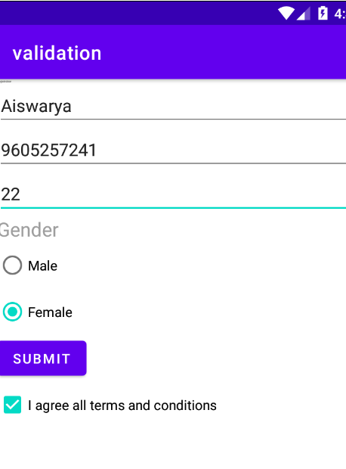

**Program No: 05 Date:26-08-2022**

**Aim**: Design a registration activity and store registration details in local memory of phone using intent and shared preferences.

**Program Code:**

**activity.xml**

*<?*xml version="1.0" encoding="utf-8"*?>*<RelativeLayout xmlns:android="http://schemas.android.com/apk/res/android"  
 xmlns:app="http://schemas.android.com/apk/res-auto"  
 xmlns:tools="http://schemas.android.com/tools"  
 android:layout_width="match_parent"  
 android:layout_height="match_parent"  
 tools:context=".MainActivity"  
 tools:ignore="HardcodedText">  
  
 <TextView  
 android:id="@+id/textview"  
 android:layout_width="wrap_content"  
 android:layout_height="wrap_content"  
 android:layout_centerHorizontal="true"  
 android:layout_marginTop="32dp"  
 android:text="Registration form"  
 android:textColor="@android:color/black"  
 android:textSize="24sp"/>  
 <EditText  
 android:id="@+id/edit1"  
 android:layout_width="match_parent"  
 android:layout_height="wrap_content"  
 android:layout_below="@+id/textview"  
 android:layout_marginStart="16dp"  
 android:layout_marginTop="8dp"  
 android:layout_marginEnd="16dp"  
 android:hint="Enter your name"  
 android:padding="10dp"/>  
 <EditText  
 android:id="@+id/edit2"  
 android:layout_width="match_parent"  
 android:layout_height="wrap_content"  
 android:layout_below="@+id/edit1"  
 android:layout_marginStart="16dp"  
 android:layout_marginTop="8dp"  
 android:layout_marginEnd="16dp"  
 android:hint="Enter your age"  
 android:padding="10dp"  
 android:inputType="number"/>  
 <EditText  
 android:id="@+id/edit3"  
 android:layout_width="match_parent"  
 android:layout_height="wrap_content"  
 android:layout_below="@+id/edit2"  
 android:layout_marginStart="16dp"  
 android:layout_marginTop="8dp"  
 android:layout_marginEnd="16dp"  
 android:hint="Enter your Email id"  
 android:padding="10dp"/>  
 <EditText  
 android:id="@+id/edit4"  
 android:layout_width="match_parent"  
 android:layout_height="wrap_content"  
 android:layout_below="@+id/edit3"  
 android:layout_marginStart="16dp"  
 android:layout_marginTop="8dp"  
 android:layout_marginEnd="16dp"  
 android:hint="Enter your Address"  
 android:padding="10dp"/>  
 <EditText  
 android:id="@+id/edit5"  
 android:layout_width="match_parent"  
 android:layout_height="wrap_content"  
 android:layout_below="@+id/edit4"  
 android:layout_marginStart="16dp"  
 android:layout_marginTop="8dp"  
 android:layout_marginEnd="16dp"  
 android:hint="Enter your gender"  
 android:padding="10dp"/>  
 <EditText  
 android:id="@+id/edit6"  
 android:layout_width="match_parent"  
 android:layout_height="wrap_content"  
 android:layout_below="@+id/edit5"  
 android:layout_marginStart="16dp"  
 android:layout_marginTop="8dp"  
 android:layout_marginEnd="16dp"  
 android:hint="Enter your Qualification"  
 android:padding="10dp"/>  
 <Button  
 android:layout_width="wrap_content"  
 android:layout_height="wrap_content"  
 android:id="@+id/b1"  
 android:layout_below="@+id/edit6"  
 android:text="Submit"/>  
</RelativeLayout>

**MainActivity.java**

package com.example.shared;  
  
import androidx.appcompat.app.AppCompatActivity;  
  
import android.content.Intent;  
import android.content.SharedPreferences;  
import android.os.Bundle;  
import android.view.View;  
import android.widget.Button;  
import android.widget.EditText;  
  
public class MainActivity extends AppCompatActivity {  
 private EditText name,age,email,address,gender,quali;  
 Button b1;  
  
 @Override  
 protected void onCreate(Bundle savedInstanceState) {  
 super.onCreate(savedInstanceState);  
 setContentView(R.layout.*activity_main*);  
 name=findViewById(R.id.*edit1*);  
 age=findViewById(R.id.*edit2*);  
 email=findViewById(R.id.*edit3*);  
 address=findViewById(R.id.*edit4*);  
 gender=findViewById(R.id.*edit5*);  
 quali=findViewById(R.id.*edit6*);  
 b1=findViewById(R.id.*b1*);  
 b1.setOnClickListener(new View.OnClickListener() {  
 @Override  
 public void onClick(View view) {  
 Intent i=new Intent(MainActivity.this,MainActivity2.class);  
 startActivity(i);  
 }  
 });  
 }  
 protected void onResume() {  
 super.onResume();  
 SharedPreferences sh = getSharedPreferences("mysharedpref", *MODE_PRIVATE*);  
 String s1 = sh.getString("name", "");  
 int a = sh.getInt("age", 0);  
 String s2 = sh.getString("email", "");  
 String s3 = sh.getString("address", "");  
 String s4 = sh.getString("gender", "");  
 String s5 = sh.getString("quali", "");  
 name.setText(s1);  
 age.setText(String.*valueOf*(a));  
 email.setText(s2);  
 address.setText(s3);  
 gender.setText(s4);  
 quali.setText(s5);  
 }  
 protected void onPause() {  
 super.onPause();  
 SharedPreferences sharedPreferences = getSharedPreferences("mysharedpref", *MODE_PRIVATE*);  
 SharedPreferences.Editor myEdit = sharedPreferences.edit();  
 myEdit.putString("name", name.getText().toString());  
 myEdit.putInt("age", Integer.*parseInt*(age.getText().toString()));  
 myEdit.putString("email", email.getText().toString());  
 myEdit.putString("address", address.getText().toString());  
 myEdit.putString("gender", gender.getText().toString());  
 myEdit.putString("quali", quali.getText().toString());  
 myEdit.commit();  
 }  
  
}

**activity_main2.xml**

*<?*xml version="1.0" encoding="utf-8"*?>*<RelativeLayout xmlns:android="http://schemas.android.com/apk/res/android"  
 xmlns:app="http://schemas.android.com/apk/res-auto"  
 xmlns:tools="http://schemas.android.com/tools"  
 android:layout_width="match_parent"  
 android:layout_height="match_parent"  
 tools:context=".MainActivity2">  
 <TextView  
 android:layout_width="wrap_content"  
 android:layout_height="wrap_content"  
 android:text="Welocome"/>  
</RelativeLayout>

**MainActivity2.java**

package com.example.shared;  
  
import androidx.appcompat.app.AppCompatActivity;  
  
import android.os.Bundle;  
  
public class MainActivity2 extends AppCompatActivity {  
  
 @Override  
 protected void onCreate(Bundle savedInstanceState) {  
 super.onCreate(savedInstanceState);  
 setContentView(R.layout.*activity_main2*);  
 }

}

**Result:** Program compiled successfully and output verified.

**Output**

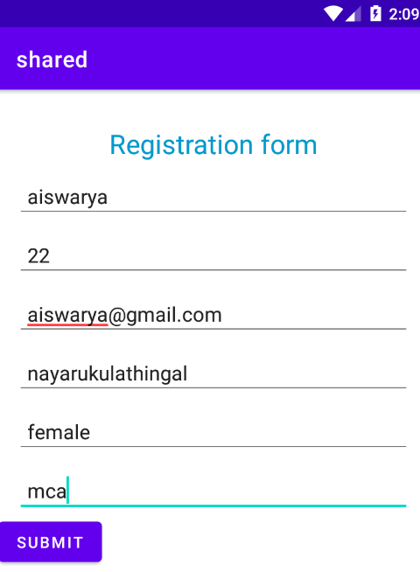

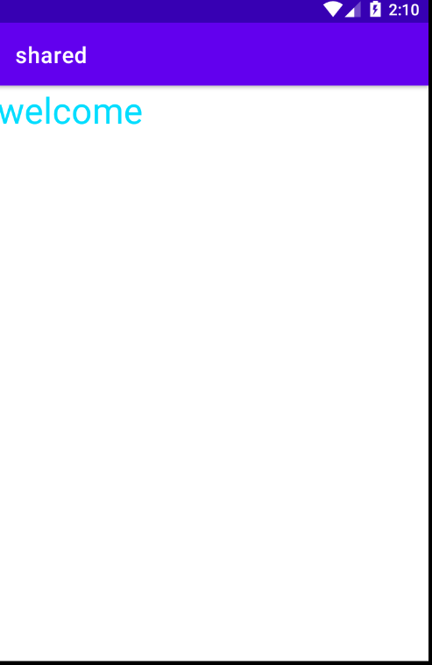

**Program No: 06 Date:30-08-2022**

**Aim**:Design a simple calculator using GridLayout.

**Program Code:**

**Activity_main.xml**

*<?*xml version="1.0" encoding="utf-8"*?>*<GridLayout xmlns:android="http://schemas.android.com/apk/res/android"  
 xmlns:app="http://schemas.android.com/apk/res-auto"  
 xmlns:tools="http://schemas.android.com/tools"  
 android:layout_width="match_parent"  
 android:layout_height="match_parent"  
 tools:context=".MainActivity">  
  
 <TextView  
 android:layout_width="wrap_content"  
 android:layout_height="wrap_content"  
 android:text="Enter 1st num"  
 android:layout_row="0"  
 android:layout_column="0"/>  
 <EditText  
 android:layout_width="wrap_content"  
 android:layout_height="wrap_content"  
 android:id="@+id/n1"  
 android:layout_row="1"  
 android:layout_column="0"/>  
 <TextView  
 android:layout_width="wrap_content"  
 android:layout_height="wrap_content"  
 android:text="Enter 1st num"  
 android:layout_row="2"  
 android:layout_column="0"/>  
 <EditText  
 android:layout_width="wrap_content"  
 android:layout_height="wrap_content"  
 android:id="@+id/n2"  
 android:layout_row="3"  
 android:layout_column="0"/>  
 <Button  
 android:text="ADD"  
 android:layout_width="wrap_content"  
 android:layout_height="wrap_content"  
 android:layout_row="4"  
 android:layout_column="2"  
 android:textColor="@color/white"  
 android:background="@color/design_default_color_error"  
 android:id="@+id/add"/>  
 <Button  
 android:text="MUL"  
 android:layout_width="wrap_content"  
 android:layout_height="wrap_content"  
 android:layout_row="4"  
 android:layout_column="1"  
 android:textColor="@color/white"  
 android:background="@color/design_default_color_error"  
 android:id="@+id/mul"/>  
 <Button  
 android:text="SUB"  
 android:layout_width="wrap_content"  
 android:layout_height="wrap_content"  
 android:layout_row="4"  
 android:layout_column="0"  
 android:textColor="@color/white"  
 android:background="@color/design_default_color_error"  
 android:id="@+id/sub"/>  
 <Button  
 android:text="DIV"  
 android:layout_width="wrap_content"  
 android:layout_height="wrap_content"  
 android:layout_row="4"  
 android:layout_column="3"  
 android:textColor="@color/white"  
 android:background="@color/design_default_color_error"  
 android:id="@+id/div"/>  
  
 <TextView  
 android:hint="Result"  
 android:width="70dp"  
 android:height="50dp"  
 android:layout_row="2"  
 android:layout_column="2"  
 android:id="@+id/result"  
 android:textColor="@color/design_default_color_error"/>  
</GridLayout>

**MainActivity.java**

package com.example.calculator;  
  
import androidx.appcompat.app.AppCompatActivity;  
  
import android.os.Bundle;  
import android.view.View;  
import android.widget.Button;  
import android.widget.EditText;  
import android.widget.TextView;  
  
public class MainActivity extends AppCompatActivity {  
  
 @Override  
 protected void onCreate(Bundle savedInstanceState) {  
 super.onCreate(savedInstanceState);  
 setContentView(R.layout.*activity_main*);  
  
  
 EditText a = findViewById(R.id.*n1*);  
 EditText b = findViewById(R.id.*n2*);  
  
  
 Button add = findViewById(R.id.*add*);  
 Button mul = findViewById(R.id.*mul*);  
 Button sub = findViewById(R.id.*sub*);  
 Button div = findViewById(R.id.*div*);  
 TextView result = findViewById(R.id.*result*);  
 add.setOnClickListener(new View.OnClickListener() {  
 @Override  
 public void onClick(View view) {  
 Double n1 = Double.*parseDouble*(a.getText().toString());  
 Double n2 = Double.*parseDouble*(b.getText().toString());  
 Double r = n1 + n2;  
 result.setText(String.*valueOf*(r));  
 }  
 });  
 sub.setOnClickListener(new View.OnClickListener() {  
 @Override  
 public void onClick(View view) {  
 Double n1 = Double.*parseDouble*(a.getText().toString());  
 Double n2 = Double.*parseDouble*(b.getText().toString());  
 Double r = n1 - n2;  
 result.setText(String.*valueOf*(r));  
 }  
 });  
 mul.setOnClickListener(new View.OnClickListener() {  
 @Override  
 public void onClick(View view) {  
 Double n1 = Double.*parseDouble*(a.getText().toString());  
 Double n2 = Double.*parseDouble*(b.getText().toString());  
 Double r = n1 * n2;  
 result.setText(String.*valueOf*(r));  
 }  
 });  
 div.setOnClickListener(new View.OnClickListener() {  
 @Override  
 public void onClick(View view) {  
 Double n1 = Double.*parseDouble*(a.getText().toString());  
 Double n2 = Double.*parseDouble*(b.getText().toString());  
 Double r = n1 / n2;  
 result.setText(String.*valueOf*(r));  
 }  
 });  
 }

}

**Result:** Program compiled successfully and output verified.

**Output**

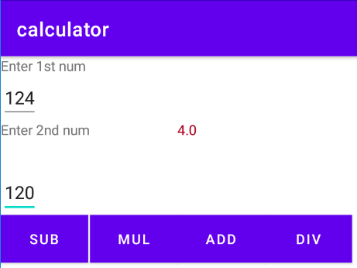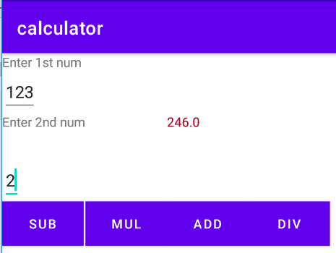

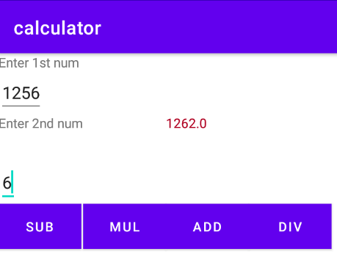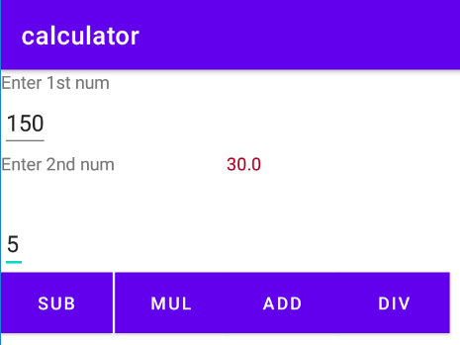

**Program No:07 Date:02-09-2022**

**Aim**:Create a facebook page using RelativeLayout ; set properties using .xml file

**Program Code:**

**Activity_main.xml**

*<?*xml version="1.0" encoding="utf-8"*?>*<RelativeLayout  
 xmlns:android="http://schemas.android.com/apk/res/android"  
 xmlns:tools="http://schemas.android.com/tools"  
 android:id="@+id/activity_main"  
 android:layout_width="match_parent"  
 android:layout_height="match_parent"  
 tools:context=".MainActivity">  
 <RelativeLayout  
 android:id="@+id/relativelayout"  
 android:layout_width="match_parent"  
 android:layout_height="wrap_content">  
 <ImageView  
 android:layout_width="match_parent"  
 android:layout_height="250dp"  
 android:id="@+id/banner"  
 android:src="@drawable/image1"  
 android:scaleType="centerCrop"/>  
 <ImageView  
 android:layout_marginLeft="15dp"  
 android:layout_width="100dp"  
 android:layout_height="150dp"  
 android:id="@+id/profilepic"  
 android:src="@drawable/images2"  
 android:layout_alignBottom="@+id/linearLayout"/>  
 <LinearLayout  
 android:layout_toRightOf="@+id/profilepic"  
 android:layout_width="match_parent"  
 android:layout_height="wrap_content"  
 android:layout_below="@+id/banner"  
 android:orientation="horizontal"  
 android:weightSum="100"  
 android:id="@+id/linearLayout">  
 <Button  
 android:layout_width="wrap_content"  
 android:layout_height="wrap_content"  
 android:text="Timeline"  
 android:textSize="5dp"  
 android:layout_weight="10"/>  
 <Button  
 android:layout_weight="10"  
 android:textSize="5dp"  
 android:layout_width="wrap_content"  
 android:layout_height="wrap_content"  
 android:text="About"/>  
 <Button  
 android:layout_weight="10"  
 android:textSize="5dp"  
 android:layout_width="wrap_content"  
 android:layout_height="wrap_content"  
 android:text="Friends"/>  
 <Button  
 android:layout_weight="10"  
 android:textSize="5dp"  
 android:layout_width="wrap_content"  
 android:layout_height="wrap_content"  
 android:text="photos"/>  
 <Button  
 android:layout_weight="10"  
 android:textSize="5dp"  
 android:layout_width="wrap_content"  
 android:layout_height="wrap_content"  
 android:text="More"/>  
 </LinearLayout>  
 <EditText  
 android:textColor="@color/white"  
 android:textStyle="bold"  
 android:layout_width="wrap_content"  
 android:layout_height="wrap_content"  
 android:inputType="textPersonName"  
 android:text="Thasni"  
 android:ems="10"  
 android:layout_alignParentEnd="true"  
 android:layout_marginEnd="55dp"  
 android:id="@+id/textName"  
 android:layout_alignBottom="@+id/banner"/>  
 </RelativeLayout>  
 <RelativeLayout  
 android:paddingRight="15dp"  
 android:paddingLeft="15dp"  
 android:paddingTop="15dp"  
 android:paddingBottom="15dp"  
 android:layout_below="@+id/relativelayout"  
 android:layout_width="match_parent"  
 android:layout_height="wrap_content">  
 <LinearLayout  
 android:layout_width="match_parent"  
 android:layout_height="wrap_content"  
 android:orientation="horizontal"  
 android:id="@+id/linearLayout2">  
 <ImageView  
 android:layout_marginLeft="5dp"  
 android:layout_marginTop="15dp"  
 android:layout_width="25dp"  
 android:layout_height="25dp"  
 android:src="@drawable/images2"/>  
 <EditText  
 android:id="@+id/etPost"  
 android:layout_marginLeft="10dp"  
 android:textSize="15sp"  
 android:layout_width="match_parent"  
 android:layout_height="60dp"  
 android:hint="What's on your mind?"/>  
 </LinearLayout>  
 <Button  
 android:textSize="10sp"  
 android:text="Post"  
 android:layout_width="70dp"  
 android:layout_height="30dp"  
 android:layout_alignParentRight="true"  
 android:layout_below="@+id/linearLayout2"/>  
 </RelativeLayout>  
</RelativeLayout>

**MainActivity.java**

package com.example.facebook;  
  
import androidx.appcompat.app.AppCompatActivity;  
  
import android.os.Bundle;  
  
public class MainActivity extends AppCompatActivity {  
  
 @Override  
 protected void onCreate(Bundle savedInstanceState) {  
 super.onCreate(savedInstanceState);  
 setContentView(R.layout.*activity_main*);  
 }  
}

**Result:** Program compiled successfully and output verified.

**Output**

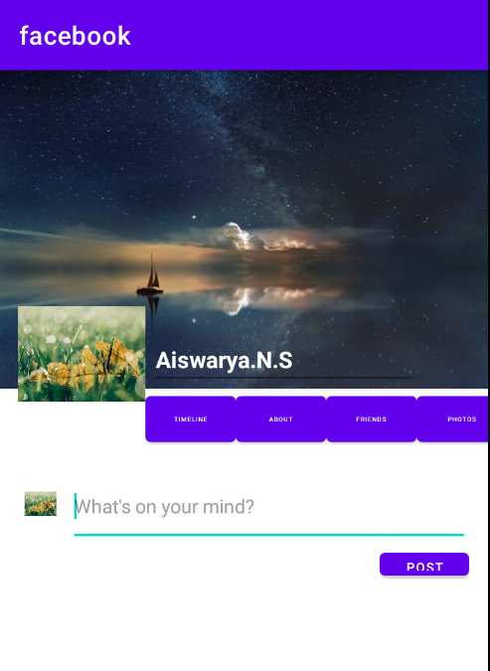

**Program No:08 Date:14-09-2022**

**Aim**:Develop an application that toggles image using FrameLayout.

**Program Code:**

**Activity_main.xml**

*<?*xml version="1.0" encoding="utf-8"*?>*<FrameLayout xmlns:android="http://schemas.android.com/apk/res/android"  
android:id="@+id/frameLayout"  
android:layout_width="fill_parent"  
android:layout_height="fill_parent">  
<ImageView  
 android:id="@+id/image1"  
 android:layout_width="match_parent"  
 android:layout_height="400dp"  
 android:scaleType="center"  
 android:src="@drawable/image1"/>  
<ImageView  
 android:id="@+id/image2"  
 android:layout_width="match_parent"  
 android:layout_height="400dp"  
 android:scaleType="centerCrop"  
 android:src="@drawable/images2"/>  
  
</FrameLayout>

**MainActivity.java**

package com.example.frame;  
  
import androidx.appcompat.app.AppCompatActivity;  
  
import android.os.Bundle;  
import android.view.View;  
import android.widget.ImageView;  
  
public class MainActivity extends AppCompatActivity {  
 ImageView i1,i2;  
  
 @Override  
 protected void onCreate(Bundle savedInstanceState) {  
 super.onCreate(savedInstanceState);  
 setContentView(R.layout.*activity_main*);  
 i1=findViewById(R.id.*image1*);  
 i2=findViewById(R.id.*image2*);  
 i2.setOnClickListener(new View.OnClickListener() {  
 @Override  
 public void onClick(View view) {  
 i2.setVisibility(view.*GONE*);  
 i1.setVisibility(view.*VISIBLE*);  
 }  
 });  
 i1.setOnClickListener(new View.OnClickListener() {  
 @Override  
 public void onClick(View view) {  
 i1.setVisibility(View.*GONE*);  
 i2.setVisibility(View.*VISIBLE*);  
 }  
 });  
 }  
}

**Result:** Program compiled successfully and output verified.

**Output**

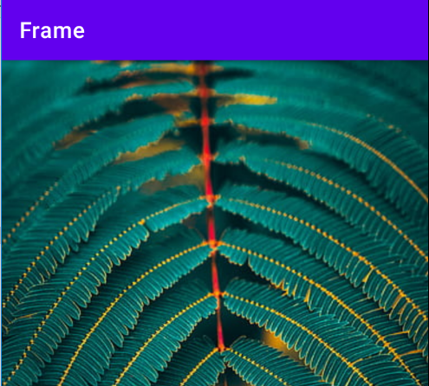

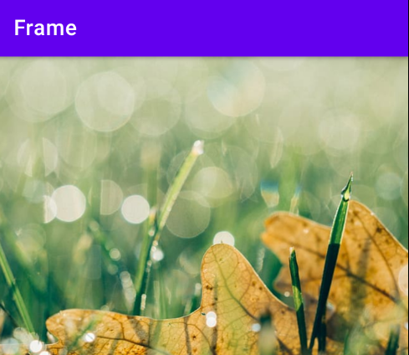

**Program No: 09 Date:16-09-2022**

**Aim**:Web application to implement implicit intent.

**Program Code:**

**activity.xml**

*<?*xml version="1.0" encoding="utf-8"*?>*<LinearLayout xmlns:android="http://schemas.android.com/apk/res/android"  
 xmlns:app="http://schemas.android.com/apk/res-auto"  
 xmlns:tools="http://schemas.android.com/tools"  
 android:layout_width="match_parent"  
 android:layout_height="match_parent"  
 tools:context=".MainActivity">  
  
 <EditText  
 android:id="@+id/t1"  
 android:layout_width="wrap_content"  
 android:layout_height="wrap_content"  
 android:text="http://www.google.co.in"  
 android:textColor="@color/design_default_color_secondary"/>  
 <Button  
 android:id="@+id/btn1"  
 android:layout_width="wrap_content"  
 android:layout_height="wrap_content"  
 android:text="click"  
 android:textColor="@color/design_default_color_error"/>  
  
</LinearLayout>

**MainActivity.java**

package com.example.implicit_intent;  
  
import androidx.appcompat.app.AppCompatActivity;  
  
import android.content.Intent;  
import android.net.Uri;  
import android.os.Bundle;  
import android.view.View;  
import android.widget.Button;  
import android.widget.EditText;  
  
public class MainActivity extends AppCompatActivity {  
 EditText et1;  
 Button b1;  
  
 @Override  
 protected void onCreate(Bundle savedInstanceState) {  
 super.onCreate(savedInstanceState);  
 setContentView(R.layout.*activity_main*);  
 et1=findViewById(R.id.*t1*);  
 b1=findViewById(R.id.*btn1*);  
 b1.setOnClickListener(new View.OnClickListener() {  
 @Override  
 public void onClick(View view) {  
 String url=et1.getText().toString();  
 Intent i=new Intent(Intent.*ACTION_VIEW*, Uri.*parse*(url));  
 startActivity(i);  
 }  
 });  
 }  
}

**Result:** Program compiled successfully and output verified.

**Output**

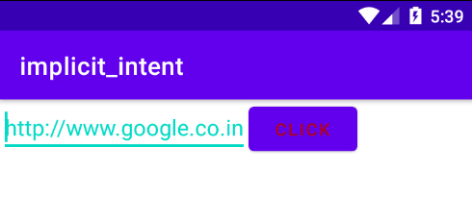

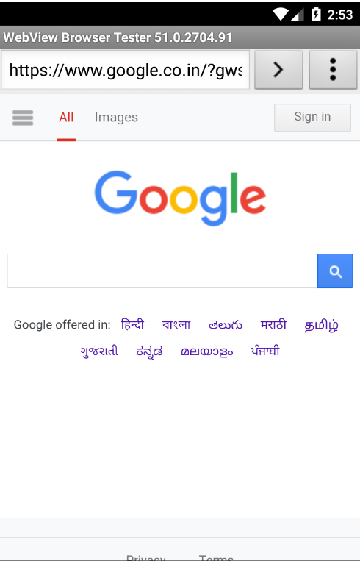

**Program No: 10 Date:20-09-2022**

**Aim**:Implement options menu to navigate two activities.

**Program Code:**

**Activity_main.xml**

*<?*xml version="1.0" encoding="utf-8"*?>*<androidx.constraintlayout.widget.ConstraintLayout xmlns:android="http://schemas.android.com/apk/res/android"  
 xmlns:app="http://schemas.android.com/apk/res-auto"  
 xmlns:tools="http://schemas.android.com/tools"  
 android:layout_width="match_parent"  
 android:layout_height="match_parent"  
 tools:context=".MainActivity">  
  
 <TextView  
 android:layout_width="wrap_content"  
 android:layout_height="wrap_content"  
 android:text="Hello World!"  
 app:layout_constraintBottom_toBottomOf="parent"  
 app:layout_constraintLeft_toLeftOf="parent"  
 app:layout_constraintRight_toRightOf="parent"  
 app:layout_constraintTop_toTopOf="parent" />

</androidx.constraintlayout.widget.ConstraintLayout>

**menu.xml**

*<?*xml version="1.0" encoding="utf-8"*?>*<menu xmlns:android="http://schemas.android.com/apk/res/android">  
 <item android:id="@+id/item1"  
 android:title="File"/>  
 <item android:id="@+id/item2"  
 android:title="Edit">  
 <menu>  
 <item android:id="@+id/sitem1"  
 android:title="Cut"/>  
 <item android:id="@+id/sitem2"  
 android:title="Copy"/>  
 <item android:id="@+id/sitem3"  
 android:title="Paste"/>  
 </menu>  
 </item>  
 <item android:id="@+id/item3"  
 android:title="View"/>

</menu>

**MainActivity.java**

package com.example.menu;  
  
import androidx.annotation.NonNull;  
import androidx.appcompat.app.AppCompatActivity;  
  
import android.os.Bundle;  
import android.view.Menu;  
import android.view.MenuItem;  
import android.widget.Toast;  
  
public class MainActivity extends AppCompatActivity {  
  
 @Override  
 protected void onCreate(Bundle savedInstanceState) {  
 super.onCreate(savedInstanceState);  
 setContentView(R.layout.*activity_main*);  
 }  
 @Override  
 public boolean onCreateOptionsMenu(Menu menu){  
 getMenuInflater().inflate(R.menu.*menu*,menu);  
 return true;  
  
 }  
 @Override  
 public boolean onOptionsItemSelected(@NonNull MenuItem item) {  
 switch (item.getItemId()) {  
 case R.id.*item1*:  
 Toast.*makeText*(getApplicationContext(), "File Selected", Toast.*LENGTH_SHORT*).show();  
 break;  
 case R.id.*item2*:  
 Toast.*makeText*(getApplicationContext(), "Edit Selected", Toast.*LENGTH_SHORT*).show();  
 break;  
 case R.id.*sitem1*:  
 Toast.*makeText*(getApplicationContext(), "Cut Selected", Toast.*LENGTH_SHORT*).show();  
 break;  
 case R.id.*sitem2*:  
 Toast.*makeText*(getApplicationContext(), "Copy Selected", Toast.*LENGTH_SHORT*).show();  
 break;  
 case R.id.*sitem3*:  
 Toast.*makeText*(getApplicationContext(), "Paste Selected", Toast.*LENGTH_SHORT*).show();  
 break;  
 case R.id.*item3*:  
 Toast.*makeText*(getApplicationContext(), "View Selected", Toast.*LENGTH_SHORT*).show();  
 break;  
  
 }  
 return super.onOptionsItemSelected(item);  
 }  
 }

**Result:** Program compiled successfully and output verified.

**Output**

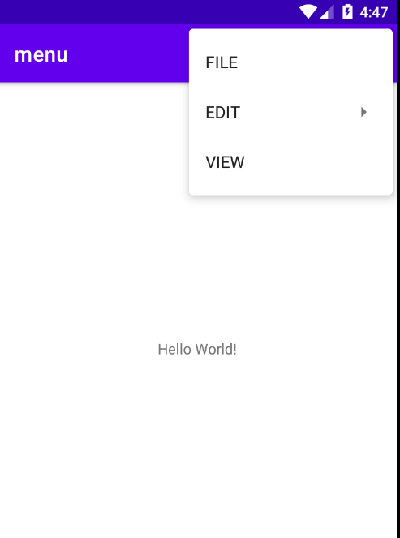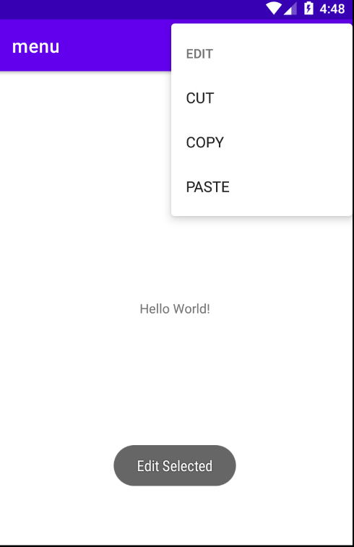

**Program No:11 Date:27-09-2022**

**Aim**: Develop an application that uses ArrayAdapter with ListView.

**Program Code:**

**Activity_main.xml**

*<?*xml version="1.0" encoding="utf-8"*?>*<LinearLayout xmlns:android="http://schemas.android.com/apk/res/android"  
 xmlns:app="http://schemas.android.com/apk/res-auto"  
 xmlns:tools="http://schemas.android.com/tools"  
 android:layout_width="match_parent"  
 android:layout_height="match_parent"  
 app:layout_behavior="@string/appbar_scrolling_view_behavior"  
 tools:context=".MainActivity"  
 tools:showIn="@layout/activity_main">  
  
 <ListView  
 android:layout_width="match_parent"  
 android:layout_height="match_parent"  
 android:id="@+id/l"/>

</LinearLayout>

**MainActivity.java**

package com.example.myapplication;  
import androidx.appcompat.app.AppCompatActivity;  
import android.content.Intent;  
import android.os.Bundle;  
import android.view.View;  
import android.widget.AdapterView;  
import android.widget.ArrayAdapter;  
import android.widget.ListView;  
  
public class MainActivity extends AppCompatActivity {  
 ListView list;  
 String[] p={"A.P.J.Abdul Kalam","Sachin Tendulkar","Jawaharlal Nehru"};  
 @Override  
 protected void onCreate(Bundle savedInstanceState) {  
 super.onCreate(savedInstanceState);  
 setContentView(R.layout.*activity_main*);  
 list=findViewById(R.id.*list*);  
 ArrayAdapter<String> adapter=new ArrayAdapter<String>(this, android.R.layout.*simple_list_item_1*,p);  
 list.setAdapter(adapter);  
 list.setOnItemClickListener(new AdapterView.OnItemClickListener() {  
 @Override  
 public void onItemClick(AdapterView<?> adapterView, View view, int i, long l) {  
 if (i==0)  
 {  
 Intent s=new Intent(MainActivity.this,MainActivity2.class);  
 startActivity(s);  
 }  
 else if(i==1)  
 {  
 Intent s=new Intent(MainActivity.this,MainActivity3.class);  
 startActivity(s);  
 }  
 else if(i==2)  
 {  
 Intent s=new Intent(MainActivity.this,MainActivity4.class);  
 startActivity(s);  
 }  
 }  
 });  
  
 }  
}

**Activity_main2.xml**

*<?*xml version="1.0" encoding="utf-8"*?>*<LinearLayout  
 xmlns:android="http://schemas.android.com/apk/res/android"  
 xmlns:tools="http://schemas.android.com/tools"  
 android:layout_width="match_parent"  
 android:layout_height="match_parent"  
 tools:context=".MainActivity2">  
  
 <TextView  
 android:layout_width="match_parent"  
 android:layout_height="match_parent"  
 android:textColor="@android:color/holo_blue_light"  
 android:text="A.P.J.ABDUL KALAM \n\n Avul Pakir Jainulabdeen Abdul Kalam (15 October 1931 – 27 July 2015) was an Indian aerospace scientist and statesman who served as the 11th President of India from 2002 to 2007. He was born and raised in Rameswaram, Tamil Nadu and studied physics and aerospace engineering. He spent the next four decades as a scientist and science administrator, mainly at the Defence Research and Development Organisation (DRDO) and Indian Space Research Organisation (ISRO) and was intimately involved in India's civilian space programme and military missile development efforts" />  
  
</LinearLayout>

**MainActivity2.java**

package com.example.myapplication;  
  
import androidx.appcompat.app.AppCompatActivity;  
  
import android.os.Bundle;  
  
public class MainActivity extends AppCompatActivity {  
  
 @Override  
 protected void onCreate(Bundle savedInstanceState) {  
 super.onCreate(savedInstanceState);  
 setContentView(R.layout.*activity_main*);  
 }  
}

**Activity_main3.xml**

*<?*xml version="1.0" encoding="utf-8"*?>*<LinearLayout xmlns:android="http://schemas.android.com/apk/res/android"  
 xmlns:app="http://schemas.android.com/apk/res-auto"  
 xmlns:tools="http://schemas.android.com/tools"  
 android:layout_width="match_parent"  
 android:layout_height="match_parent"  
 tools:context=".MainActivity3">  
  
 <TextView  
 android:layout_width="match_parent"  
 android:layout_height="match_parent"  
 android:textColor="@android:color/holo_orange_dark"  
 android:text="SACHIN TENDULKAR \n\n Sachin Ramesh Tendulkar AO BR (born 24 April 1973) is an Indian former international cricketer who captained the Indian national team. He is regarded as one of the greatest batsmen in the history of cricket. He was a right-handed top-order bastmen in the Indian Cricket Team. He is known for his batting skills, technique, vision and game reading. He is the all time most runscorer in both ODI and Test Format with more then 18000 runs and 15000 runs respectively in total. He also holds the record for receiving most Man-of-the-match awards in International Cricket with all forms combined." />  
</LinearLayout>

**MainActivity3.java**

package com.example.myapplication;  
  
import androidx.appcompat.app.AppCompatActivity;  
  
import android.os.Bundle;  
  
public class MainActivity extends AppCompatActivity {  
  
 @Override  
 protected void onCreate(Bundle savedInstanceState) {  
 super.onCreate(savedInstanceState);  
 setContentView(R.layout.*activity_main*);  
 }  
}

**Activity_main4.xml**

*<?*xml version="1.0" encoding="utf-8"*?>*<LinearLayout xmlns:android="http://schemas.android.com/apk/res/android"  
 xmlns:app="http://schemas.android.com/apk/res-auto"  
 xmlns:tools="http://schemas.android.com/tools"  
 android:layout_width="match_parent"  
 android:layout_height="match_parent"  
 tools:context=".MainActivity4">  
 <TextView  
 android:layout_width="match_parent"  
 android:layout_height="match_parent"  
 android:textColor="@android:color/holo_green_dark"  
 android:text="Jawaharlal Nehru was born in Allabahad on November 14, 1889. He received his early education at home under private tutors. At the age of fifteen, he went to England and after two years at Harrow, joined Cambridge University where he took his tripos in Natural Sciences."/>  
</LinearLayout>

**MainActivity4.java**

package com.example.myapplication;  
  
import androidx.appcompat.app.AppCompatActivity;  
  
import android.os.Bundle;  
  
public class MainActivity extends AppCompatActivity {  
  
 @Override  
 protected void onCreate(Bundle savedInstanceState) {  
 super.onCreate(savedInstanceState);  
 setContentView(R.layout.*activity_main*);  
 }  
}

**Result:** Program compiled successfully and output verified.

**Output**

